BUSINESS PLAN TEMPLATE
Applied Software Development – University of the Highlands and Islands

ADD a FRONT COVER

CONTENTS PAGE

Executive Summary

Business Description

Market Analysis

Competitor Analysis

Marketing & Sales Strategy

Product Development & Technology

Operations Plan

Financial Plan

Risk Analysis

Meta Skills Reflection

Conclusion

References

Executive Summary
Brief overview of the project, its goals, and key value proposition.

Business Description
Describe the business idea, mission statement, and the problem your software addresses.
The business idea is to mitigate social media and general phone addiction in a way that promotes digital wellbeing, encourages carbon literacy and reconnects users with the natural world.
Media apps are designed for endless scrolling, but every minute carries an unseen cost – to our attention, wellbeing, and the planet. The MauiScreenTime app aims to equip users with an oversight of the greater impact of their digital habits, and empowering user with tools to mitigate phone overuse and become more informed consumers of social media.

Market Analysis
Outline your target market, customer segments, and demand for your product. This will be covered through your work with Vickie!
- Vicky will do with us

Competitor Analysis
Identify key competitors and analyze their strengths, weaknesses, and market position.
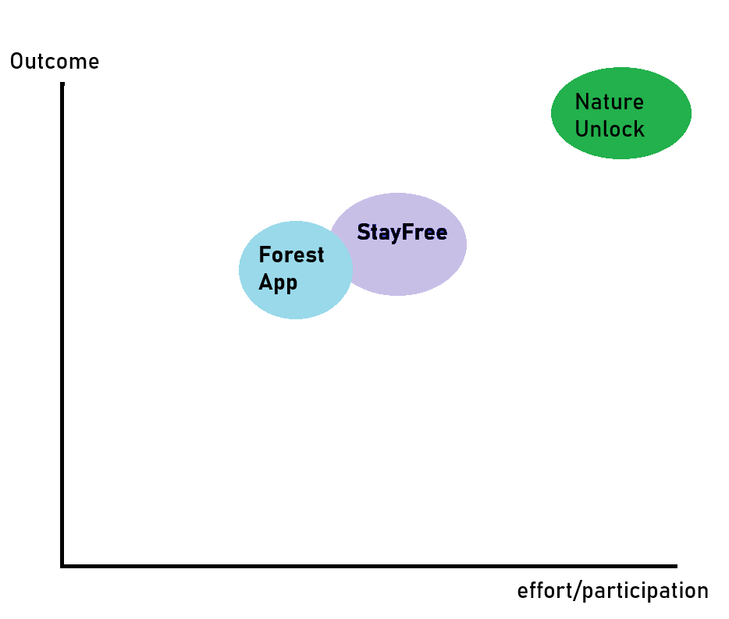
Figure 1: Group Mapping Analysis (Keenan, 2026)
Measured against axes of user effort/participation vs the outcome of the participation, there are two distinct groups.
Nature Unlock requires users to go outside, take a picture of a tree and upload it to unlock their phones. This is a high effort, high yield model of operation that rewards the user with a healthy beneficial experience.
StayFree is more moderate and allows users to block apps with a number of different settings and controls available to tailor the experience to user needs.
Forest App is another, marginally less effort and lower yield service which encourages users to use their pomodoro-style timer by “growing” a virtual tree for the duration of the timer, restricting access to other apps.
From this analysis it can be determined there are three distinct areas that can be moved into: High effort low yield, low effort low yield, and low effort high yield.
As our application requires mostly passive participation and offers a high-impact physical outcome comparative to competitors, I think MauiScreenTime could fit well into the low effort, high yield corner of the market.

Marketing & Sales Strategy
Explain how you will promote, price, distribute, and sell your software product.
Will be promoted to Inverness campus specifically but also on Linkedin. With sustainable flyers for in-person that include the logo and QR code for download, stall with materials to explain the product to potential users, screenshots of the app printed to demonstrate. Small learning materials? Monetised user incentives for participating, 1st, 2nd, 3rd prize for who can plant the most trees, potentially runner up prizes for top 10.
Possibility also to create a social media presence for the application, where for example an Instagram profile can be created and advertisements paid to target audience members who actively use the apps this project aims to monitor and reduce the usage of.
Look at the forest.cc app

Product Development & Technology
Describe the software solution, its main features, technology stack, and development methodology (e.g., Agile/Scrum).
The software solution tracks user screen time spent on Social Media apps, quantifies it into CO2eq, and gamifies the reduction of screen-time with the incentive of planting trees for x amount of CO2eq “saved” from a decrease in use of social media applications.
To support this, the project main features are a user consent system to allow for legal data collection, a screen time usage collection service, CO2eq conversions with numerical goals and milestones, and a dashboard for reporting this data.
The project uses C# .NET MAUI cross-platform framework with SQLite for local, on-device data storage, and the source code is hosted on Github for source control. The project follows Agile Scrum, with frequent feedback loops from stakeholders and team members at the end of sprints to inform development as it moves forward.

Operations Plan
Summarize the development timeline, resources, tools used, and daily operations of the project.
Four releases of the project from initial design planning to fully tested release span at around 2 months each, prioritising core application logic and then refining it into an intuitive and effective UI/UX. The resources used are student manpower, guidance from delivery staff and using Github source control with JIRA for project management, the Visual studio IDE and MS Teams to communicate. The daily operations of the project are to check communications, work from JIRA tickets in Visual Studio and to commit progress to Github.

Financial Plan
Estimate development costs, projected revenue (if applicable), and resource allocation.
Add Budget tracker here?
Include budget tables, break-even analysis, and assumptions if possible.
– Ben will help with
Budget for rebel fund (Lois wants it to show how it’s funded)
Current funding for the project proof of concept includes £2500 from Prickly Thistle.
The funding stipulation excludes coursework from payment, and so only non-technical elements of the project development will be funded. Funding also excludes paid labour, and therefore only materials and event support are funded.
It’s estimated the average cost for a recommended 1000-1600 trees per hectare is around £900-2000 (https://www.woodlandtrust.org.uk/plant-trees/trees-for-landowners-and-farmers/morewoods/#:~:text=On%20average%2C%20self%2Dplanted%20projects,landowner%20around%20%C2%A3900%2D2%2C000.)
Around this estimate and adhering to the funding available, a cash-flow document has been created. (https://github.com/TortoiseLeaf/laurenk_personal_repository_2025/blob/main/UI_Software_Project_Initiation_and_Planning/cash-flow-maui.xlsx)

For further development beyond the proof of concept, further avenues of funding have been researched in UHI’s Staff & Student enterprise fund, where a further £3000 - £5000 has been applied for in order to support feature development and integration of user feedback to strengthen and stabilise the platform.
Beyond strengthening the proof-of-concept, UHI’s converge competition has been considered for long term maintenance and future development of the project, including exploring avenues of partnership with more local conservation initiatives and eventually modelling the software for enterprise adoption.

Risk Analysis
Identify potential risks (technical, market, financial) and your mitigation strategies.
A risk register was made with the team to identify, prioritise and offer mitigations for various risks to both development and project management, and also to external operations of the project such as the conservation event (Keenan. 2025).

Meta Skills Reflection
Reflect on the soft skills developed during the project, such as:
☐ Critical thinking
☐ Problem-solving
☐ Teamwork & communication
☐ Adaptability
☐ Time management
☐ Self-motivation
Describe how these skills were applied and improved throughout the project. Use the meta-skills tools provided to assist you.
Skills I identified as weaker and to develop have been leading, collaborating, critical thinking and initiative. In making an effort to develop these skills I have found that my skills in leading have been developed by being more conscious and considered about collaborating, which has helped me develop an understanding of when and how to lead and what is necessary to step forward into to push development forward.
Similarly I have found that focussing on developing my leading and collaboration skills have greatly improved my critical thinking, because as a topic is discussed and passed between hands I have found it allows me to step back from the issue and see it from different perspectives. Also by sharing the responsibility for the idea discussed, my personal resources around considering the topic are freed up, and I notice I have more mental bandwidth to consider the topic critically. It also helps immensely to see things from another persons perspective, particular way of thinking or skill-set.
I have found that leading and collaborating have also informed my ability to take initiative and I’ve noticed a big development here also, as understanding my place at different levels within a team has given me a greater insight into what actions I can take and where, to create more effective and positive change. This is also helping me develop a confidence in understanding where my initiative is best placed, as project sprints progress.
Link the meta skills pdf

Conclusion
Summarize the overall value of the project, its potential impact, and future development opportunities. This may include insights, recommendations for next steps e.g. prototyping/launching in the market etc.

References

Keenan, L. (2025) laurenk_personal_repository_2025/UI_Enterprise_Transformation /LO1.xlsx, laurenk_personal_repository_2025/UI_Enterprise_Transformation /LO1.xlsx at main. Available at: https://github.com/TortoiseLeaf/laurenk_personal_repository_2025/blob/main/UI_Enterprise_Transformation/LO1.xlsx (Accessed: 26 November 2025).

